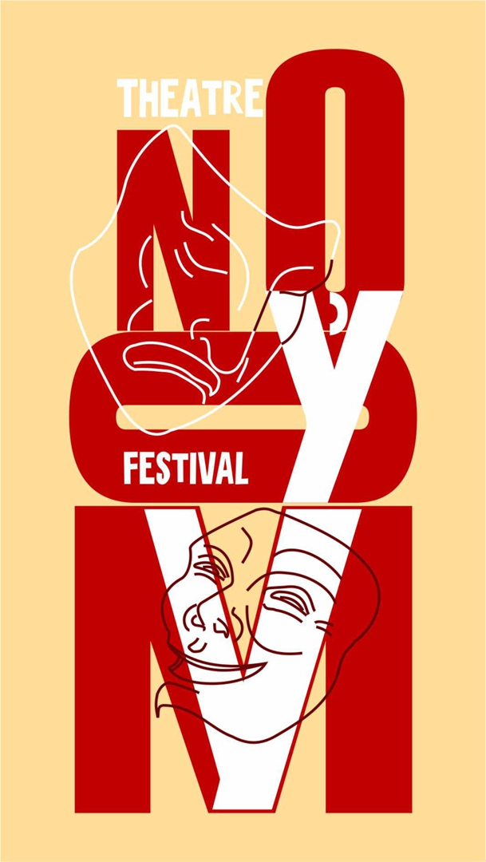 | APPLICATION FORM  УMOЎNO, Amateur theatre festival  POLACK, BELARUS, NOVEMBER 12–14, 2021  This form should be sent by October 1, 2021 to Anastasiya Mazgo  E-mail: polackzviaz@gmail.com  nastenka.mazgo@gmail.com

THE GROUP

Name of the group:
Contact person:
Address:
Telephone number:
e-mail:
Home page:

Brief history of the group:

Director of the group

Name:
Address:
Telephone number:
e-mail:

THE PLAY

Title of the performance:
Author:
Duration of the performance:
Style:
Language:
Synopsis:

TECHNICAL REQUIREMENTS

Stage space:
Setting up time:
Striking time:
Lighting (please send technical details):

LIST OF PARTICIPANTS (TO BE SENT LATER)

Ms.,  Mr., | Name | First name | Age | Languages  Spoken | Function in the show

